Prince Sefa

JUSTIT bootcamp |

**Assignment 1: Data Story Telling**

Consolidation Project 1:

Table of Contents

**Policies and Procedures** 2

**Excel** 3

The data

Reflective

Task 1:

Policies and Procedures

Data can be presented in a variety of forms and then interpreted and read depending on how it is displayed. The proper visualisation of data is a powerful way for people, especially data professionals, to display data so that it can be interpreted easily. It helps tell a story with data, by turning spreadsheets of numbers into stunning graphs and charts. These visualizations allow us to easily understand any patterns, trends, or outliers in a data set. Data visualization also presents data to the general public or specific audiences without technical knowledge in an accessible manner and can be used to help drive informed decision-making and even to add colourful meaning to an otherwise bland database.

Raw data can be hard to comprehend and use so to be able to show data in a visual form helps us easily identify the relationships between data and detect patterns or trends, for example. There are numerous visualisation tools and software which can be used to suit data presentation specifications. Tableau is a powerful open-source data visualisation package that renders information in a visual format such as a graph, chart, or heat map for data analysis purposes and therefore makes it easier to understand and work with massive amounts of data.

In the pursuit of creating insightful and reliable data visualizations using Tableau, it is necessary to adhere to a set of fundamental policies and best practices which are to be followed. These guidelines ensure the integrity, privacy, and ethical use of the data we are about to explore, When analysing data sourced from geopolitical standpoints such as the wealth of nations around the world, we need to be sure to follow a proper set of data analysing policies and procedures which can be used to craft insightful and trustworthy visualisations. Such policies and procedures are as follows:

* Data Privacy and Compliance: We should prioritize compliance with data privacy regulations, safeguarding individual rights and data security.
* Data Quality and Cleaning: Rigorous data cleaning and pre-processing eliminate inaccuracies, inconsistencies, and outliers. Data validation guarantees accuracy and reliability.
* Data Source Attribution: Properly attribute the source of our data, acknowledging its origin and validity.
* Data Security: Robust security measures are in place to prevent unauthorized access and protect data from breaches.
* Data Collection and Granularity: We determine the appropriate level of data aggregation or granularity to meet our analysis objectives.
* Data Visualization Guidelines: We follow data visualization best practices, using suitable chart types, colour coding, and labelling for clear communication. Misleading visualizations are avoided.
* Data Ethics: Ethical considerations are central, ensuring that our analysis does not perpetuate bias, discrimination, or harmful stereotypes.
* Data Access Control: Access to data is controlled, and limited to authorized personnel to maintain security.

By upholding these principles, we create a robust foundation for the data visualization journey ahead. Our commitment to these policies ensures that the insights we derive are accurate, unbiased, and ethically sound.

Task 2

## Excel

In correspondence with the GDP tasks stated for the assignment, I will be including screenshots depicting each task set and how I arrived at such.

1. Screenshot showing sheet protected:

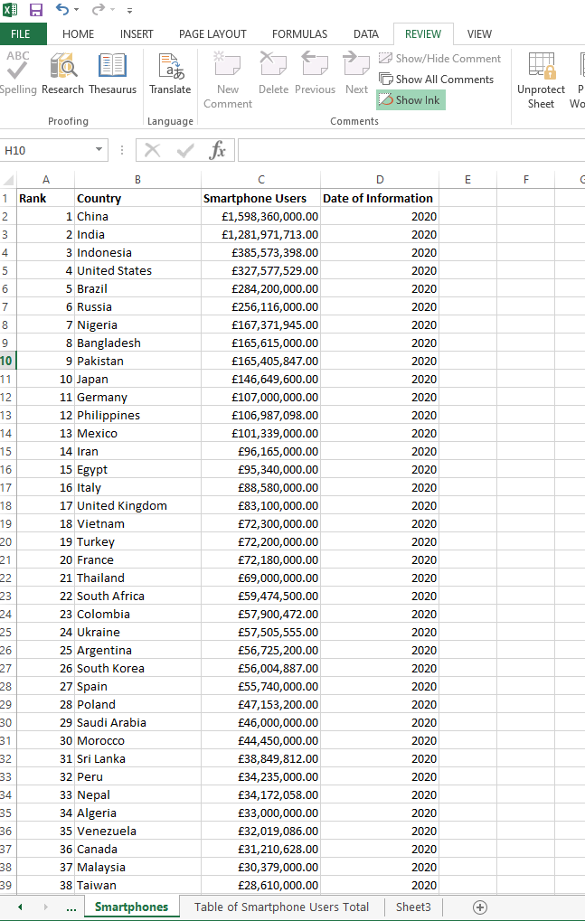

1. Column C data formatted to display in British Pound: 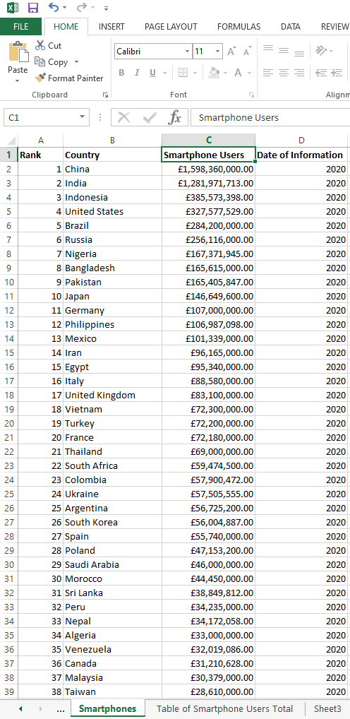
2. Table showing GDP Per Capita (PPP) for countries over the years

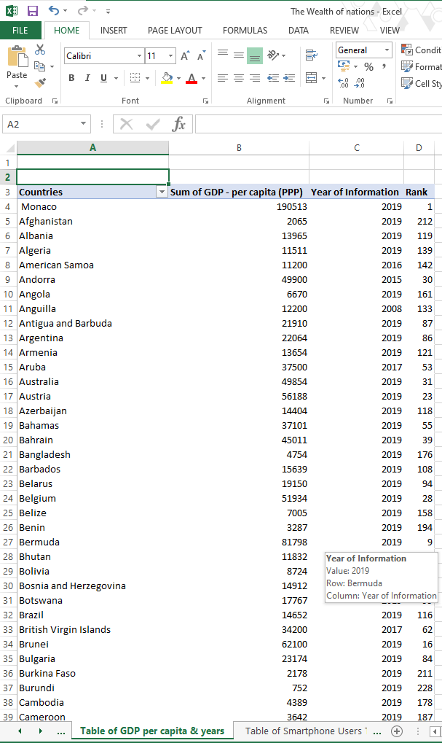

1. Table showing data filtered to show information for a specific date (2019)

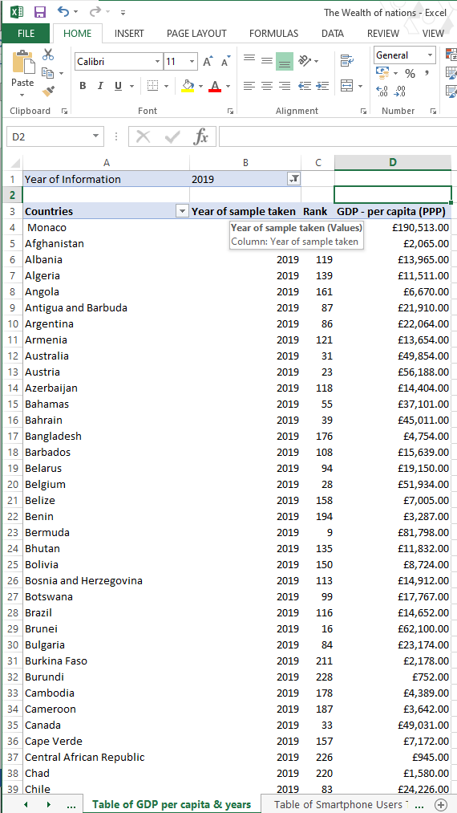

1. Chart displaying Country GDP data and rankings:

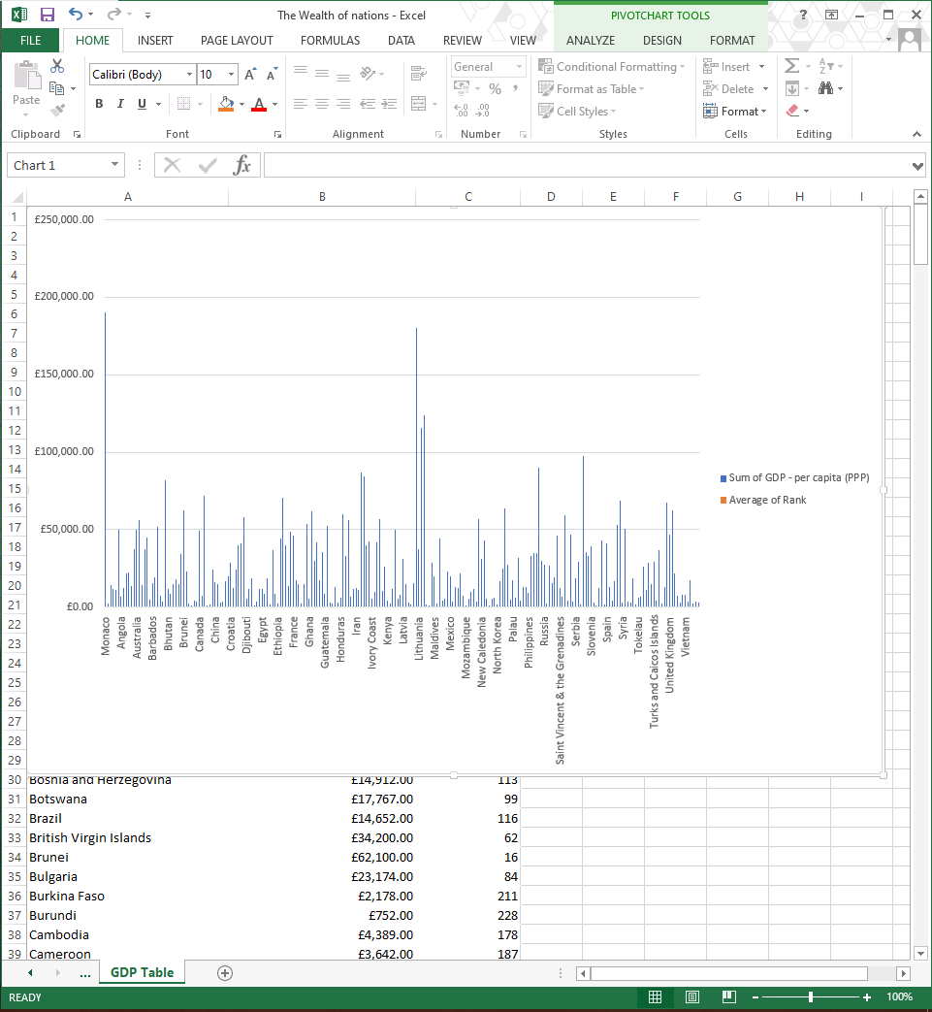

1. Edited Chart of “Rank, Country and GDP- Per Capita” with title, X and y axis labels and visuals:

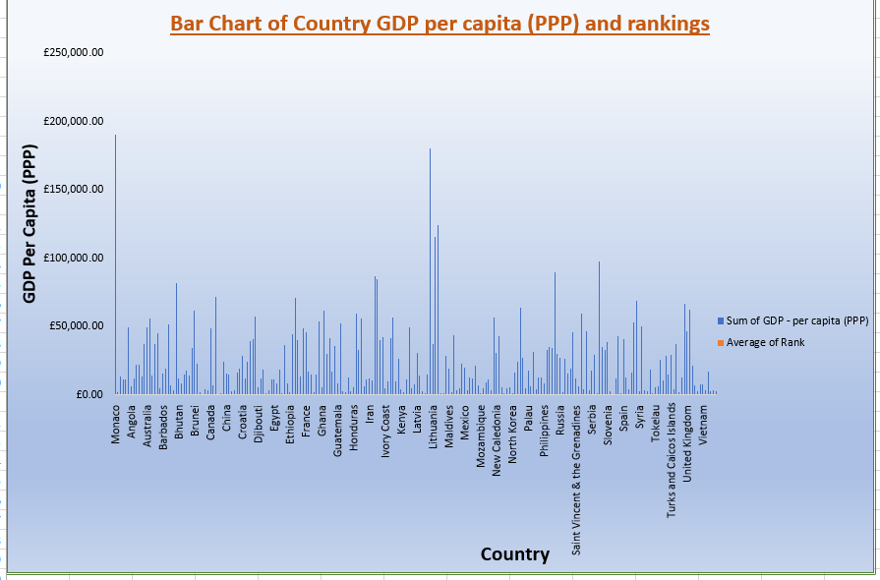

1. Chart on new worksheet with appropriate sheet name:

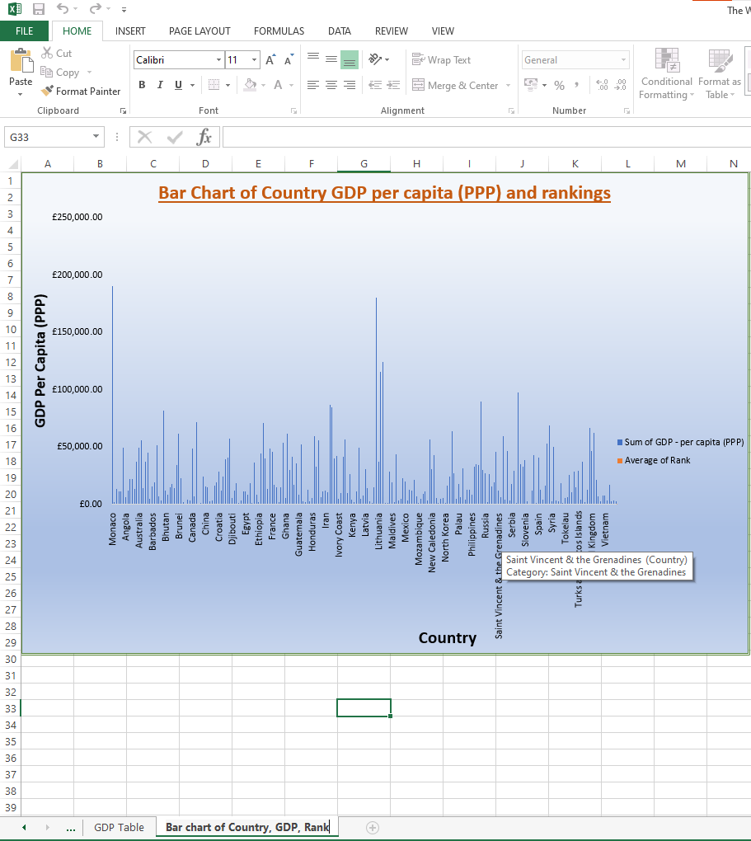

1. 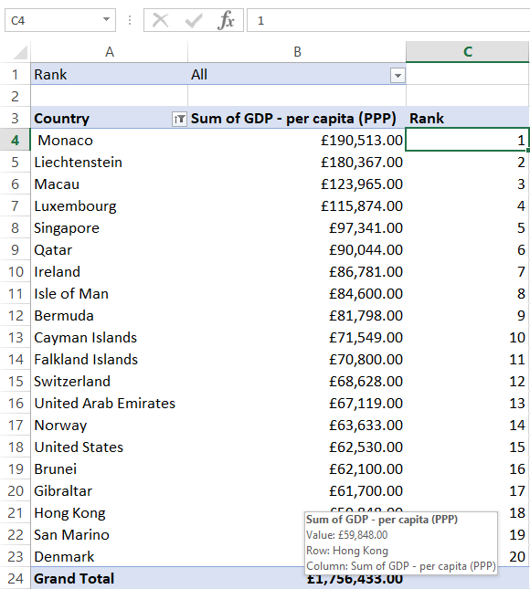Top 20 Highest Ranking Countries:
2. Bar chart to display the 20 highest ranking countries from sort

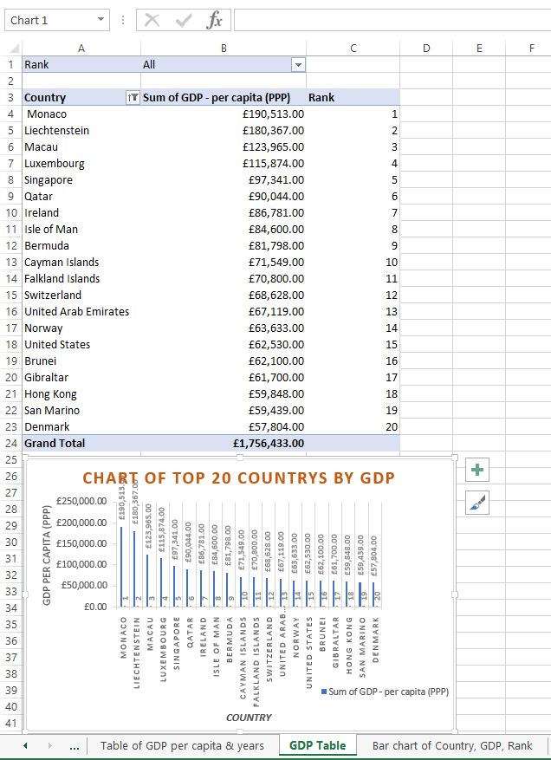

1. 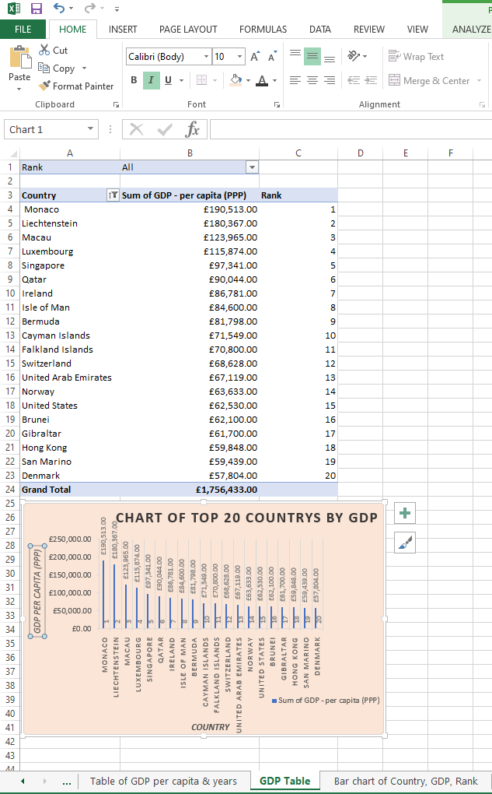Background colour formatting area underneath table

Task 2

The data

